ITU - Telecommunication Standardization Sector Temporary Document 0308rev1
STUDY GROUP 8

Geneva, 2 - 10 February 2000

Question: 4/8

SOURCE*: EDITOR

TITLE: T.38 IMPLEMENTOR’S GUIDE

(Approved by Study Group on 10 February 2000)
__________________

- TPKT
1.1 Issue Overview
Other H.323 protocols such as H.225 and H.248 utilize the TPKT header with TCP. It also provides Application Layer Framing.
1.2 Proposal
T.38 will be amended at some point in the future to address this issue. Implementors should implement the TPKT header as defined in RFC1006. While few implementations based on the 1998 version are known, implementors are also advised to properly handle messages that do not include the TPKT header. Section 7.1.3 of T.38 and Figure 4 will be modified as followed.

7.1.3 IFP Packet Layers for TCP/IP and UDP/IP
The IFP packets described in 7.2 are combined with the appropriate headers for TCP/IP and UDP/IP as shown in Figures 4 and 5. In Figure 5, the UDPTL header represents the additional header information required for error control over UDP. To provide interoperability in H.323 environments, the TPKT header defined in RFC1006 shall precede the IFPacket in TCP implementations as shown in Figure 4.
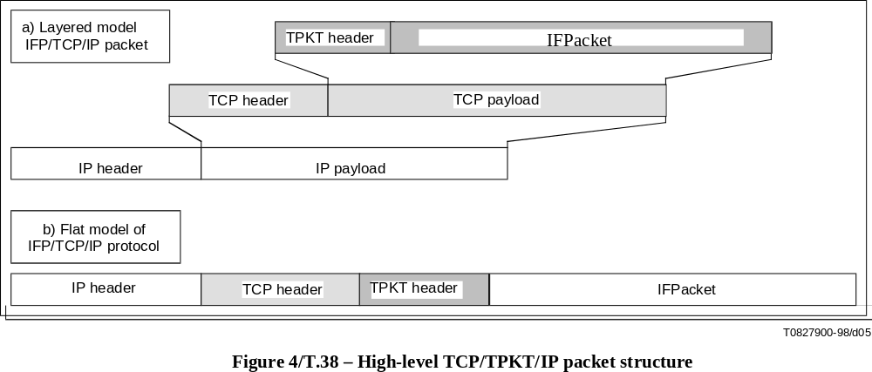
- Internet Aware Fax Device Support
2.1 Issue Overview
The operation of Internet Aware Fax (IAF) Devices is not fully specified in T.38, particularly in the area of IAF inter-working with PSTN based G3FE devices
2.2 Proposal
Additional text is proposed to amend T.38 to clarify the operation and interworking of Internet Aware Fax (IAF) devices. Bits are being added to Table 2/T.30 for DIS/DCS negotiation to identify IAF devices. Note T.38 Appendix 1 shows an example of an IAF device as the receiving device.
The following note is added to Table 2/T.38:
Note: If both G3FE devices are identified via DIS/DCS exchange as Internet-Aware Fax Devices, T30_INDICATOR use is optional with UDP
The following note is added to Table 4/T.38:
Note: If both G3FE devices are identified via DIS/DCS exchange as Internet-Aware Fax Devices, T30_DATA values shall be ignored
Sections 8.1 and 8.2 describing Data Rate Management, are expanded to clarify the behavior of the IAF devicesData rate management method 1
8.1 Data rate management method 1
Method 1 of data rate management requires that the TCF training signal be generated locally by the receiving gateway. Data rate management is performed by the emitting gateway based on training results from both PSTN connections.
Method 1 is used for TCP implementations and is optional for UDP implementations.
When a CFR (Confirmation to receive) or an FTT (failure to train) is received from a G3FE at the receiving gateway, a T.30 HDLC packet (indicating CFR or FTT respectively) should be forwarded to the emitting gateway.
According to the result of a TCF received from a G3FE and the T.30 HDLC packet (CFR or FTT) forwarded from a receiving gateway, an emitting gateway transmits FTT or CFR according to Table 6.

Table 6/T.38 – Decision table of signalling rate of an emitting gateway
T.30 signal  message forwarded  from receiving gateway | TCF signal  received from a G3FE  at emitting gateway | Signal to be  transmitted  to G3FE (emitter)
CFR | Success | CFR
FTT | Success | FTT
CFR | Failure | FTT
FTT | Failure | FTT
In the case where the Emitting Device is an Internet Aware Fax (IAF) device and there is no Emitting Gateway, the IAF device shall respond to FTTs from the Receiving Gateway with appropriate DCS responses, including possibly modulation changes.
In the case where the Receiving Device is an Internet Aware Fax (IAF) device and there is no Receiving Gateway, the IAF device shall respond to DCS from the Emitting Gateway with CFR, but shall be prepared for a DCS in case the Emitting Gateway generates an FTT.

In the case where the Emitting Device and the Receiving Device are IAF devices, the Emitting Device shall send DCS with the modulation bits set to 0, and the Receiving Device shall respond with CFR. The data rate over the IP network is established during Call Setup.8.2 Data rate management method 2
Data rate management method 2 requires that the TCF be transferred from the sending G3FE to the receiving G3FE rather than having the receiving gateway generate it locally. Speed selection is done by the G3FEs in the same way as they would on a regular PSTN connection.
In the case where the Emitting Device is an Internet Aware Fax (IAF) device and there is no Emitting Gateway, the IAF device shall respond to FTTs from the Receiving Gateway with appropriate DCS + TCF responses, including possibly modulation changes.
In the case where the Receiving Device is an Internet Aware Fax (IAF) device and there is no Receiving Gateway, the IAF device shall respond to DCS from the Emitting Gateway with either CFR or FTT, depending upon the received TCF signal.
In the case where the Emitting Device and the Receiving Device are IAF devices, the Emitting Device shall send DCS with the modulation bits set to 0, and the Receiving Device shall respond with CFR. The data rate over the IP network is established during Call Setup.
Data Rate Management Method 2 is mandatory for use with UDP but it is not recommended either for use with TCP, or for the case where both G3FE devices are identified via DIS/DCS exchange as Internet-Aware Fax devices.

- TCP Start-up
3.1 Issue Overview
The start-up of the TCP channel for the IFPackets is not clearly defined in H.323 (1999).
3.2 Proposal
Please refer to the latest H.323 Implementor’s Guide.

___________________

